Off-line Lab 3 Exercise

Scope Management

*After completing this lab session, you should be able to:*

* *Create a new project file*
* *Develop a work breakdown structure (WBS), and*
* *Set a baseline to help plan and manage a project*

# Introduction to Project Scope Management

Project scope management defines the work to perform a service or product development in a project. This chapter guides you through several steps to create your scope management using an open source application tool named as ProjectLibre. Open your ProjectLibre and click at the Create Project Icon to create a new project file.

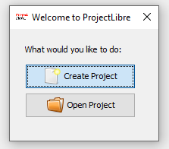

Figure 1: Open or Create a Project Dialog Box

After clicked the Create Project button, insert your file name “**scope_***your group name***. pod**”**,** *insert the manager’s name*, the finished date of the final work developed in the project as illustrated in Figure 2.

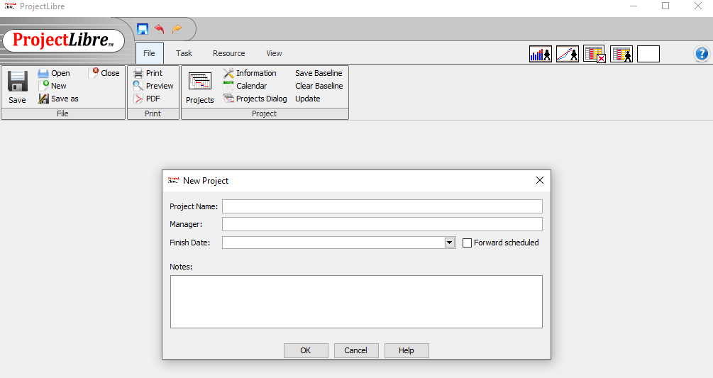

Figure 2: ProjectLibre Main User Interface

After finish enter the detail’s information (as in Figure 2), then the work structure that has been brainstorm during Assignment 1 need to be put inside the ProjectLibre project management application tool. The sample of information to be put in the project starts with:

1. Initiation Phase
2. Acquisition and Development Phase
3. Implementation
4. Operation and Management
5. Disposition.

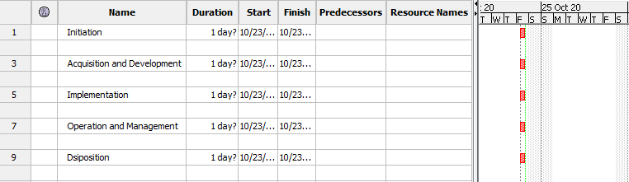

Figure 3: ProjectLibre Main User Interface

Then, the project manager needs to insert the details security solutions or products proposed for your client as in Figure 4.

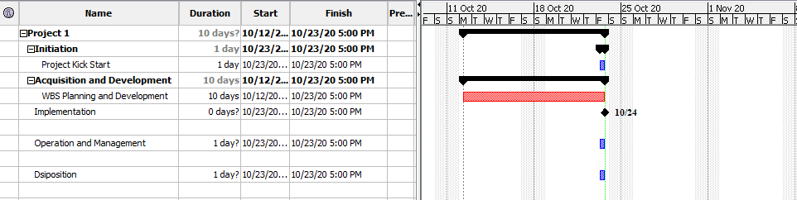

Figure 4: Sample of information based on security life-cycle phases

After finished insert all information in the project management application tool (ProjectLibre), it is important in Project Management to track the project performance against a baseline or approved plan. This software will not prompt you to save a project with or without a baseline each time you save it; hence the default is to save without a baseline.

It is important for you to finalise your project before you save with a baseline since it shows changes against a baseline. Since you are still developing this project, you have to save the file without a baseline. Later if the project is approved, you can save it with baseline. Figure 5 shows the output to save the project as a baseline.

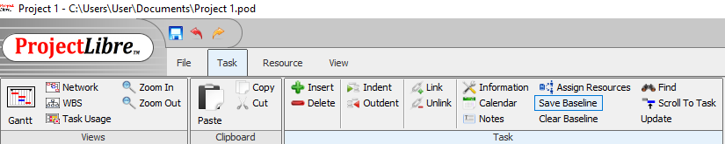

Figure 5: Save the project as a Baseline

# Develop Work Breakdown Structure

Developing good WBS takes time and entering tasks into the Entry table is much easier if you have planned your WBS first. It is also a good idea to establish milestones before entering tasks in ProjectLibre. Table 1 is sample tasks that you should use in entering tasks for **Project Network Security for Client**. This sample task is simple and general that acts as a guide for you to start inserting the information into the ProjectLibre.

Table 1 – Sample Tasks of Project Network Security for Client

|  |  |  |  |
| --- | --- | --- | --- |
| **ORDER** | **TASKS** | **ORDER** | **TASKS** |
| 1 | Initiating | 11 | Design |
| 2 | Kickoff meeting | 12 | Implementation |
| 3 | Develop project charter | 13 | System implemented |
| 4 | Charter signed | 14 | Controlling |
| 5 | Planning | 15 | Report Performance |
| 6 | Develop project plans | 16 | Control changes |
| 7 | Review project plans | 17 | Closing |
| 8 | Project plans approved | 18 | Prepare final project report |
| 9 | Executing | 19 | Present final project |
| 10 | Analysis | 20 | Project Completed |

Follow this step-by-step instruction in order to develop WBS and enter milestones for this project.

1. Enter all tasks in Table 1 into the **Task Name** Column as shown in Figure 4. Ignore other information at this time. Press **Enter** or **down arrow key** to move to the next row. If you accidentally skip a task, highlight the task row and select Insert from the menu bar, the select New Task to insert a blank row. To edit a task entry, click the text for that task, click the Entry bar under the formatting toolbar to either type over the old text or edit the existing text.
2. If needed, you can move the split bar to the right to reveal the entire Task Name and Duration columns.
3. The next step is to show the WBS levels by creating the summary tasks. In this example, the summary tasks are Task 1 (initiating), 5 (acquisition and development), 9 (implementation), 12 (operation and management), and 15 (dispositions).